Computer Network lab
Name: Ayush Ravindra Patil
Date: 17-09-26
Practical: 3

Aim: Implementation of two-way Client/Server communication using TCP
Socket.

1] Server (Code):
import socket
server = socket.socket(socket.AF_INET, socket.SOCK_STREAM)
server.bind(("127.0.0.1", 8080))
server.listen(1)
print("Server is waiting for connection....")

conn, addr = server.accept()
print("Connected with: ", addr)
while True:
client_msg = conn.recv(1024).decode()
print("Client: ", client_msg)
if client_msg.lower() == "exit":
break
reply = input("Server: ")
conn.send(reply.encode())
if reply.lower() == "exit":
break
conn.close()
server.close()

Output:
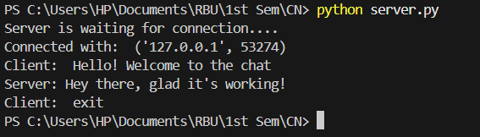

1] Client (Code):
import socket
client = socket.socket(socket.AF_INET, socket.SOCK_STREAM)
client.connect(("127.0.0.1", 8080))
print("Connected to Server."
while True:
message = input("Client: ")
client.send(message.encode())
if message.lower() == "exit":
break
reply = client.recv(1024).decode()
print("Server: ", reply)
if reply.lower() == "exit":
break
client.close()

Output:
